## **CHAPTER 2**

## **LITERATURE REVIEW/BACKGROUND STUDY**

A literature review or background study of a company portfolio website is an analysis of the relevant research, articles, and publications that relate to the purpose, design, and content of the website. It is an important component of the planning and development process for the website and helps to identify best practices and potential pitfalls.

Overall, a literature review or background study of a company portfolio website should provide a comprehensive overview of the current trends, strategies, and best practices for designing and implementing a successful portfolio website.

### **2.1. Timeline of the reported problem**

The timeline of the reported problem should include a historical overview of the company's industry or market.

### **2.2. Existing solutions**

There are several existing solutions available for creating a company portfolio website. Some of the most popular options include:

**Custom-built websites:** Companies can hire a web development agency or freelance developer to create a custom portfolio website that is tailored to their specific needs and branding. This option allows for maximum flexibility and control over the website's design and functionality.

**Content management systems (CMS):** Popular CMS platforms such as WordPress, Wix, and Squarespace offer pre-designed templates and drag-and-drop tools that make it easy for companies to create a portfolio website without any coding skills. These platforms also offer various plugins and integrations that enhance the website's functionality.

**Website builders:** Website builders like Weebly, GoDaddy, and Shopify offer pre-designed templates and simple drag-and-drop tools that allow companies to create a portfolio website quickly and easily. These platforms are especially useful for small businesses or individuals who want to create a professional-looking website without a lot of technical knowledge.

**Portfolio platforms:** There are several portfolio-specific platforms, such as Behance, Dribbble, and Carbonmade, that allow creative professionals to showcase their work to potential clients and collaborators. These platforms typically offer a range of templates, tools, and social sharing options that make it easy to create an engaging and visually stunning portfolio website.

### **2.3. Bibliometric analysis**

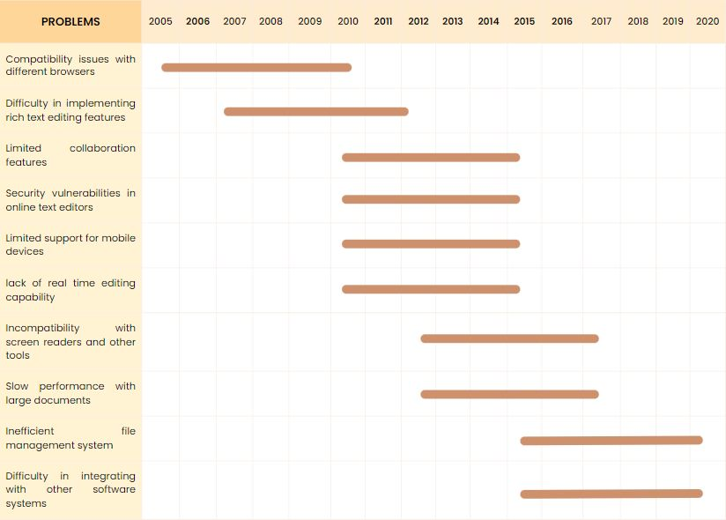

# Bibliography

Al-Tabbaa, O. a. (2021). Nonprofit organizations and social-alliance portfolio size: Evidence from website content analysis. Industrial Marketing Managemen, 147--160.

Fahril, M. a. (2021). Rancang Bangun Sistem Informasi Company Profile Berbasis Web Pada Pt. Gotrans Logistics: Web-Based Company Profile Information System Design At PT. Gotrans Logistics. Indonesian Journal of Informatic Research and Software Engineering (IJIRSE), 45--52.

Hidayatullah, R. A. (2016). LKP: Pembuatan Desain Website Sebagai Penunjang Company Profile CV. Hensindo. S1 Desain Komunikasi Visual.

Izzah, A. (2021). Pengembangan Web Company Profile Terintegrasi Dengan API WhatsApp (Studi Kasus: Agen Sembako Al-Barkah). INFOTECH journal, 40--44.

Smolkin, R. (2006). Adapt or die: as newspaper companies confront a challenging future, they are increasingly viewing their trademark print product as the engine driving a diverse" portfolio" that embraces other" platforms" such as Web sites and niche publications. Is this a. American Journalism Review, 16--24.

### **2.4. Review Summary**

[**B Hernández**](https://scholar.google.com/citations?user=19O2PpQAAAAJ&hl=en&oi=sra) **:** The design of a quality website, as part of e-business strategy, has become a key element for success in the online market. This article analyzes the main factors that must be taken into account when designing a commercial website, concentrating on the Aceros de Hispania company and its business model. We have studied the features which determine website quality: accessibility, speed, navigability, content, and we have calculated the Web Assessment Index (WAI) proposed by Miranda and Bañegil [Miranda, F. J., and Bañegil, T. M. (2004). Quantitative evaluation of commercial websites: An empirical study of Spanish firms. *International Journal of Information Management*, *24*(4), 313–328]. The results obtained provide several lessons which should be borne in mind when designing a commercial e-strategy.

[**L Vaughan**](https://scholar.google.com/citations?user=gKwgzUMAAAAJ&hl=en&oi=sra)**– Scientometrics :** Two previous webometrics studies found a relationship between the number of inlinks to a commercial site and the company's business performance measures. Thus inlink counts to commercial sites could be a potential source of business information. However, those studies examined top ranking information technology companies in the U.S. and China. Whether the above-mentioned relationship holds for all companies regardless of ranking and in other countries is unknown. The study reported in this paper investigated this question.

**HA Wan - Information & management :** This article describes a framework of analysis that categorizes features of website design in a matrix of business functions versus customer values. The framework supports a development plan for a commercial website that may involve all aspects of a transaction. It also includes examples of Web features that could be evaluated from the visitor or customer perspective. As customers might have a different view from the company, the framework chooses Web features that are directly related to customer values: those which may bring only strategic advantages to the company but are intangible to customers are deliberately ignored.

[**M Perry**](https://scholar.google.com/citations?user=bOcwOz4AAAAJ&hl=en&oi=sra)**, C Bodkin - Corporate Communications :** Discusses the results of content analysis of the Web sites of *Fortune* 100 companies, carried out to identify the mix of promotional activities on their Web sites. Specifically, we performed a content analysis of Web sites utilizing categories representing a range of marketing communications, including: communicating product, pricing and dealer/retail location information, related and unrelated advertisements, sales promotion, direct marketing, basic company information and public relations. We also identified differences between and among industries based on standard industrial classification (SIC) codes. We found considerable variability in how members of the *Fortune* 100 used their Web sites. The Web sites ranged from very simple ones that focused on basic company information, such as company history, to quite complex Web sites that incorporated a mix of promotional elements, such as press releases, advertisements, games, free gifts and pricing information

### **2.5. Problem Definition**

The company is facing a challenge in effectively showcasing its work and services to potential clients. The current website does not adequately represent the company's brand identity and does not effectively communicate its values and mission. The website also lacks a clear and concise message and has a cluttered and confusing design, making it difficult for visitors to navigate and find the information they need.

In addition, the current website does not effectively generate new business leads or attract potential clients. The lack of high-quality visual content and responsive design also makes it difficult for the company to stand out from competitors in the market.

To address these challenges, the company needs to develop a new portfolio website that effectively represents its brand identity, communicates its values and mission, and showcases its work and services in a memorable and engaging way. The website should be visually appealing, user-friendly, and optimized for search engines to attract potential clients and generate new business leads. The website should also incorporate analytics tools to track user behaviour and preferences and make data-driven decisions to optimize its effectiveness.

By addressing these challenges through the development of a new portfolio website, the company can improve its online presence, effectively showcase its work and services to potential clients, and generate new business leads to support its growth and success in the market.

### **62.6. Goals/Objectives**

**Goals:**

* To showcase the company's work and services in an engaging and memorable way.
* To attract potential clients and generate new business leads through the portfolio website.
* To establish the company's brand identity and communicate its values and mission to potential clients.
* To provide a user-friendly experience that encourages visitors to explore the website and learn more about the company.
* To optimize the website's design and content to increase traffic, engagement, and conversion rates.

**Objectives:**

* Develop a clear and concise brand message that effectively communicates the company's values and mission.
* Create a visually appealing and professional design that highlights the company's work and services.
* Incorporate high-quality visual content, such as photos, videos, and infographics, to showcase the company's work and services.
* Design a responsive website that adapts to different screen sizes and devices.

Implement user-friendly navigation and search features to make it easy for visitors to find the information they need.